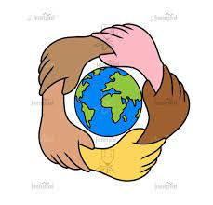
Victoria CP School - Curriculum Rationale
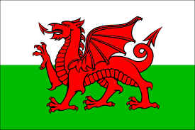
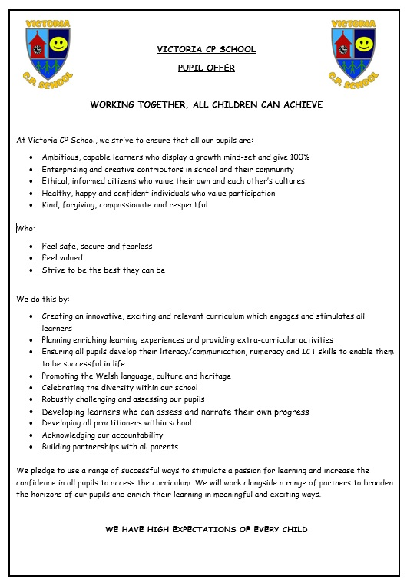

At Victoria CP School, we deliver an engaging and meaningful curriculum that meets the needs of all learners. Our creative curriculum is local yet global and it will provide our learners with the skills, experiences and knowledge to empower them to embrace an ever-changing world with critical minds, positivity and hope.

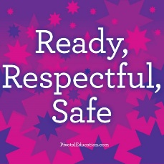
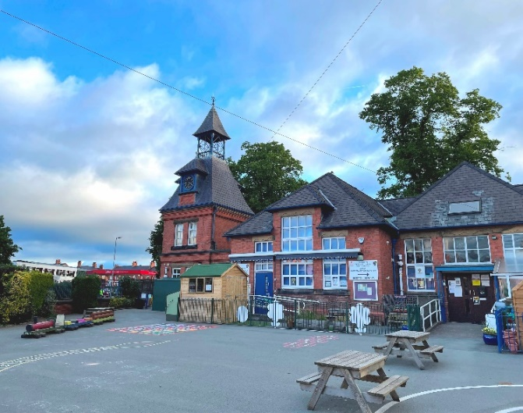
Time
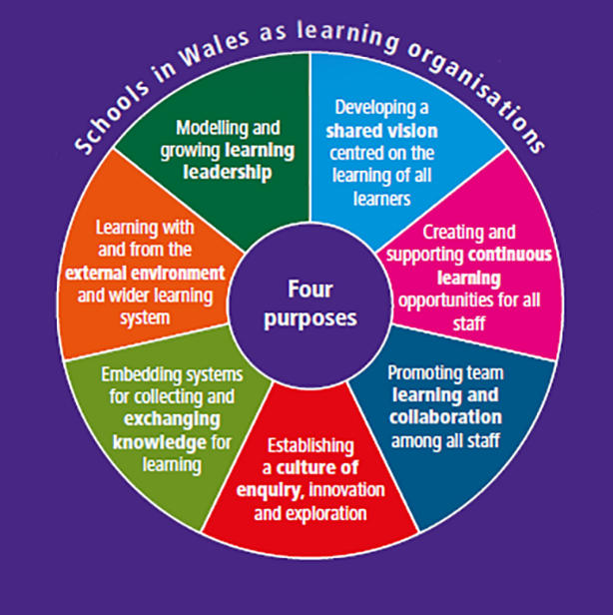
Trust

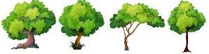
Tech
Thinking
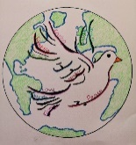
Drwy gydweithio, gall pob plentyn llwyddo.
School Context
Ysgol Victoria is situated in the town centre of Wrexham and is maintained by Wrexham local authority. We are an inclusive and diverse school with over 22 nationalities represented, including asylum seekers and refugees. The locality is classed as neither an advantaged or disadvantaged area. Our school serves the town centre and outlying villages including Offa, Erddig, Hightown, Rhostyllen, Bersham and Brymbo. We have 468 pupils on roll, including 56 full-time nursery children which makes us one of the biggest primary schools in Wrexham. We have 16 classes and we are 2-form entry. We are an English medium primary school and none of our pupils speak Welsh at home. 36% of our pupils are from an ethnic minority or mixed background and we see this number increasing year on year which is very exciting for us. 18% of our pupils are learning English as an additional language and they are well supported by our EAL team. About 22% of our children are eligible for FSM and 16% of pupils are on the school’s additional learning needs register. None of our pupils have a statement of special educational needs.
Estyn Summary, April 2019
Most pupils, including those with additional learning needs or who have English as an additional language, make good progress while at the school. The school provides a safe and caring environment and nearly pupils behave well and have positive attitudes to their learning. Teachers provide interesting and appropriately challenging activities that encourage pupils to develop their literacy and numeracy skills well, often in imaginative and stimulating contexts. The school’s arrangements for care, support and guidance promote pupils’ development as rounded and resilient individuals effectively. The headteacher has established a strong ethos of teamwork where all staff share good practice and curricular innovation. A well-informed governing body supports the school effectively.
The school was last inspected in April 2019 and was judged as ‘Good’ in all areas.
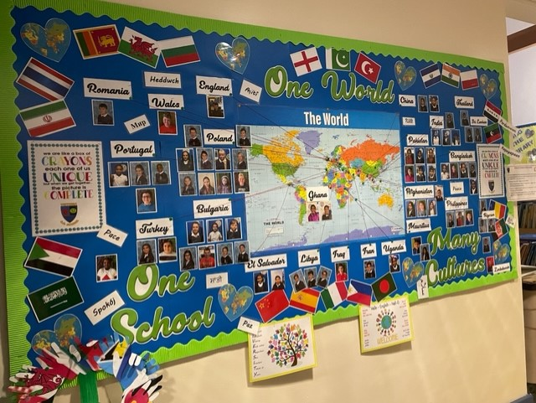

.
The Four Purposes of the Curriculum
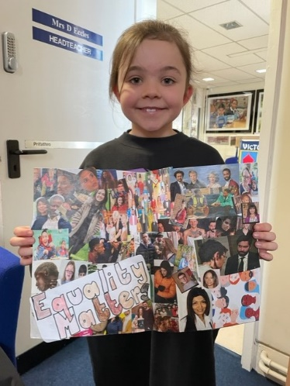
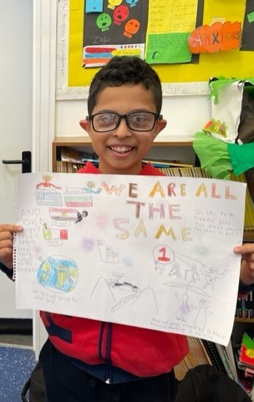

Purpose - At Victoria CP School, we deliver an engaging and meaningful curriculum that meets the needs of all learners. Our creative curriculum is local yet global and it will provide our learners with the skills, experiences and knowledge to empower them to embrace an ever-changing world with positivity and hope
AMBITIOUS & CAPABLE LEARNERS:
- set themselves high standards and seek and enjoy challenge
- are building up a body of knowledge and have the skills to connect and apply that knowledge in different contexts
- are questioning and enjoy solving problems
- can communicate effectively in different forms and settings, using both Welsh and English
- can explain the ideas and concepts they are learning about
- can use number effectively in different contexts
- understand how to interpret data and apply mathematical concepts
- use digital technologies creatively to communicate, find and analyse information
- undertake research and evaluate critically what they find

ENTERPRISING & CREATIVE CONTRIBUTORS:
- connect and apply their knowledge and skills to create ideas and products
- think creatively to reframe and solve problems
- identify and grasp opportunities
- take measured risks
- lead and play different roles in teams effectively and responsibly
- express ideas and emotions through different media
- give of their energy and skills so that other people will benefit
ETHICAL & INFORMED CITIZENS:
- find, evaluate and use evidence in forming views – engage with contemporary issues based upon their knowledge and values
- understand and exercise their human and democratic responsibilities and rights
- understand and consider the impact of their actions when making choices and acting
- are knowledgeable about their culture, community, society and the world, now and in the past
- respect the needs and rights of others, as a member of a diverse society
- show their commitment to the sustainability of the planet
HEALTHY & CONFIDENT INDIVIDUALS:
- have secure values and are establishing their spiritual and ethical beliefs
- are building their mental and emotional well-being by developing confidence, resilience and empathy
- apply knowledge about the impact of diet and exercise on physical and mental health in their daily lives
- know how to find the information and support to keep safe and well
- take part in physical activity
- take measured decisions about lifestyle and manage risk
- have the confidence to participate in performance
- form positive relationships based upon trust and mutual respect
- face and overcome challenge
- have the skills and knowledge to manage everyday life as independently as they can

The 6 Areas of Learning
Health & Wellbeing | Languages, Literacy & Communication | Mathematics and Numeracy | Science & Technology | Expressive Arts | Humanities
Physical health  Mental health  Emotional & Social Wellbeing | English, Welsh & International Languages | Understanding concepts, using symbols, fluency, reasoning & strategic competence | Biology, Chemistry, computer Science, Design & Technology & Physics | Art, Music, Dance, Drama, Film & Digital Media | Geography, History, Religion, Values & Ethics, Business, Social Studies, Economics & Philosophy

Cross-Curricular Skills
Literacy | Numeracy | Digital Competence

Integral Skills
Creativity | Inquire, explore, be curious, share ideas, link experiences, knowledge and skills
Critical thinking and problem solving | Question and evaluate information and situations, identify problems and suggest different solutions, make decisions objectively
Personal Effectiveness | Develop emotional intelligence, confidence and independence, evaluate current learning and next steps, celebrate mistakes,
Planning & Organisation | Set goals for their learning and discuss and reflect on their progress
Cross-cutting Themes
Relationships and Sexuality Education (RSE) | Human Rights and Rights of the Child | Diversity | Careers and Work Related Experience | Local, National and International Context
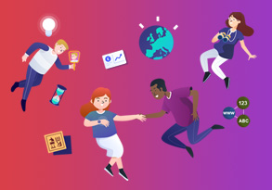
Curriculum for Wales – What Matters?
Humanities Statements of what matters

- Enquiry, exploration and investigation inspire curiosity about the world, its past, present and future.
- Events and human experiences are complex, and are perceived, interpreted and represented in different ways.
- Our natural world is diverse and dynamic, influenced by processes and human actions.
- Human societies are complex and diverse, and shaped by human actions and beliefs.
- Informed, self-aware citizens engage with the challenges and opportunities that face humanity, and are able to take considered and ethical action.

Science and Technology - Statements of what matters
- Being curious and searching for answers is essential to understanding and predicting phenomena.
- Design thinking and engineering offer technical and creative ways to meet society’s needs and wants.
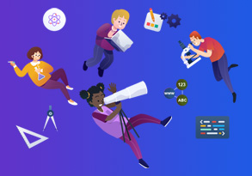
- The world around us is full of living things which depend on each other for survival.
- Matter and the way it behaves defines our universe and shapes our lives.
- Forces and energy provide a foundation for understanding our universe.
- Computation is the foundation for our digital world.

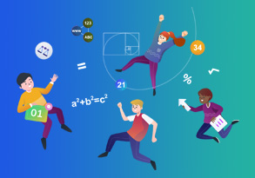
Maths - Statements of what matters
- The number system is used to represent and compare relationships between numbers and quantities.
- Algebra uses symbol systems to express the structure of mathematical relationships.
- Geometry focuses on relationships involving shape, space and position, and measurement focuses on quantifying phenomena in the physical world.
- Statistics represent data, probability models chance, and both support informed inferences and decisions.

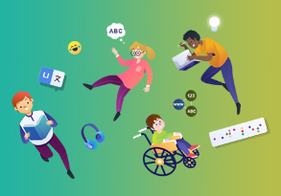
Literacy and Language - Statements of what matters
- Languages connect us.
- Understanding languages is key to understanding the world around us.
- Expressing ourselves through languages is key to communication.
- Literature fires imagination and inspires creativity.

Expressive Arts - Statements of what matters
- Exploring the expressive arts is essential to developing artistic skills and knowledge and it enables learners to become curious and creative individuals.
- Responding and reflecting, both as artist and audience, is a fundamental part of learning in the expressive arts.
- Creating combines skills and knowledge, drawing on the senses, inspiration and imagination.

Health & wellbeing - Statements of what matters
- Developing physical health and well-being has lifelong benefits.
- How we process and respond to our experiences affects our mental health and emotional well-being.
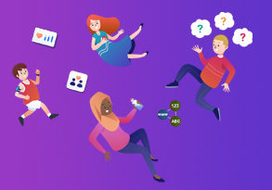
- Our decision-making impacts on the quality of our lives and the lives of others.
- How we engage with social influences shapes who we are and affects our health and well-being.
- Healthy relationships are fundamental to our well-being.

Learning Powers at Victoria Primary School

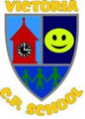
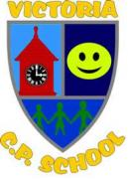
Concentrate | Don’t give up | Be cooperative | Be curious | Have a go | Use your imagination | Keep improving | Enjoy learning
Manage distractions.  Dive beneath the surface to see more.  Do one thing at a time.  Break things down.  Plan & think it through.  Draw diagrams, jot down thoughts or things that help you think.  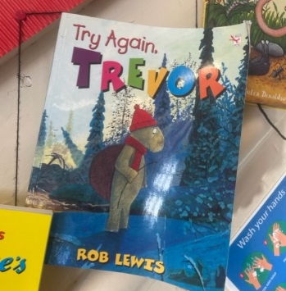 | Work hard.  Practise lots.  Keep going.  Try new strategies.  Ask for help.  Start again.  Take a brain break. | Listen to others.  Say when you don’t understand.  Be kind when you disagree.  Explain things to help others.  Be tolerant.  Take on a role. | Ask questions.  Notice things.  Look for patterns and connections.  Think of possible reasons.  Research.  Ask what if…?  Record your thoughts.  Ask different points of view. | Have a growth mindset.  Don’t worry if it goes wrong.  Learn from mistakes.  Be excited to try new things. | Be creative.  Let your imagination go.  Think up new ideas and questions.  Enjoy free time to explore, discuss & share.  Allow yourself to think more deeply. | Keep reviewing your work.  Identify your best bits.  Improve one thing first.  Try to be better than last time.  Don’t compare yourself to others; only yourself.  Set yourself targets. | Feel proud of your achievements.  Imagine your intelligence growing by the minute.  Use what you have learnt in real life.  Know that you can do it if you have input and practise.  Give learning a chance!  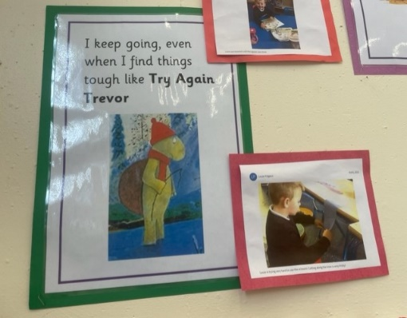

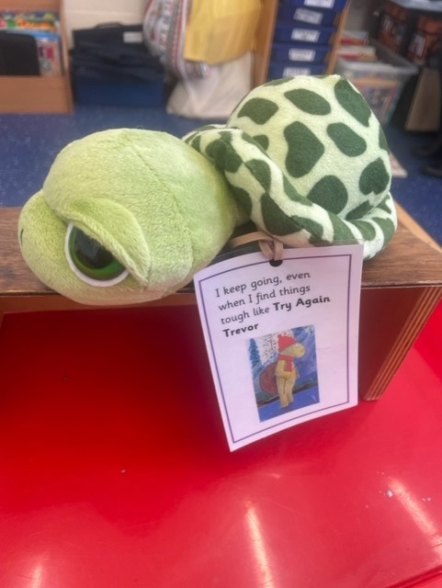

No curriculum can come to life without pedagogy. The curriculum is the map of learning and pedagogy is the vehicle. We use a wide range of teaching and learning approaches that suit the learners in our class. This ensures that our learners are receiving a more personalised curriculum.
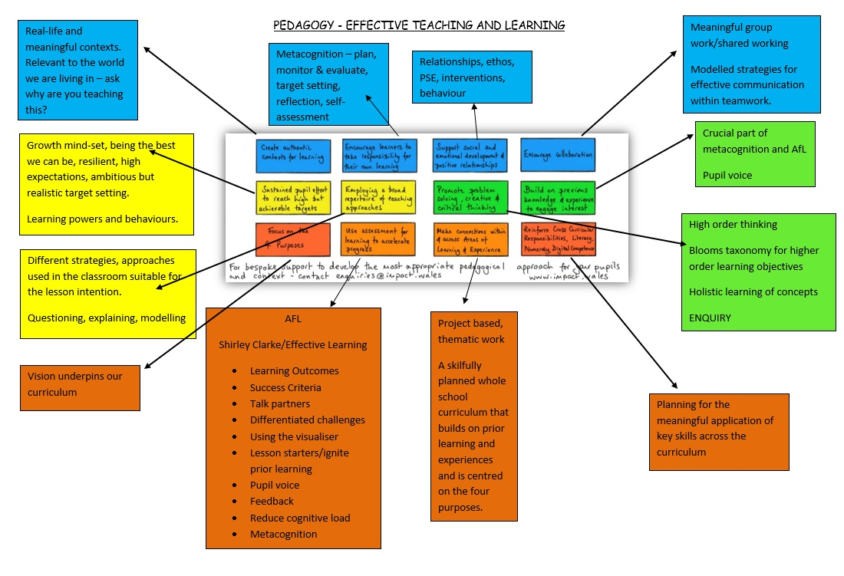

Our Curriculum at Victoria CP School
The four purposes underpin all of our teaching and learning at Victoria CP School. For our youngest children in Nursery, we follow Planning in the Moment where we capture teachable moments from the interests of the child in the present moment. This child-led learning gains momentum as our children move through the infant department. Alongside this, we focus on developing basic skills through a multi-disciplinary approach. We implement a strong transition between year 2 and 3, where year 3 adopt many FP approaches with a focus on basic skills. By the time our children reach upper KS2, they are experiencing more of a disciplinary approach to their learning which will prepare them for high school.

At Victoria CP School, we deliver an engaging, inclusive and meaningful curriculum that meets the needs of all learners. Our creative curriculum is local and community focused, yet global and it will provide our learners with the skills, experiences and knowledge to empower them to embrace an ever-changing world with critical minds, positivity and hope. We are a school that places as much importance on children’s well-being as it does on academic success. Our curriculum is alive and evolving. It is responsive to the needs of our pupils. It is a fluid and flexible machine which may alter direction according to the needs of the class or cohort. Above all, it has coherence, credibility and compassion and encourages learners to engage with their head, heart and hands.

What we teach isn't the most important factor - it is how we teach it where our effort and focus lies. We focus on 'learning to' not 'learning about'. We understand that learning is a very personal journey for every child and we respond to the individual needs of our learners using a wealth of pedagogical approaches of which investing in, and building positive relationships, is the main approach to engaging our children. Their progression is our mission and ensuring our children independently navigate their own learning journey throughout their time at Victoria School is of utmost importance. This can only be achieved through mutual trust and high expectations of all.

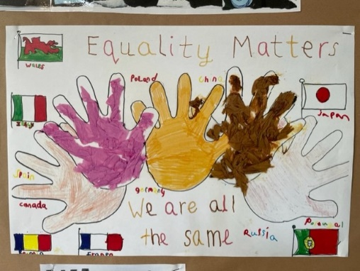
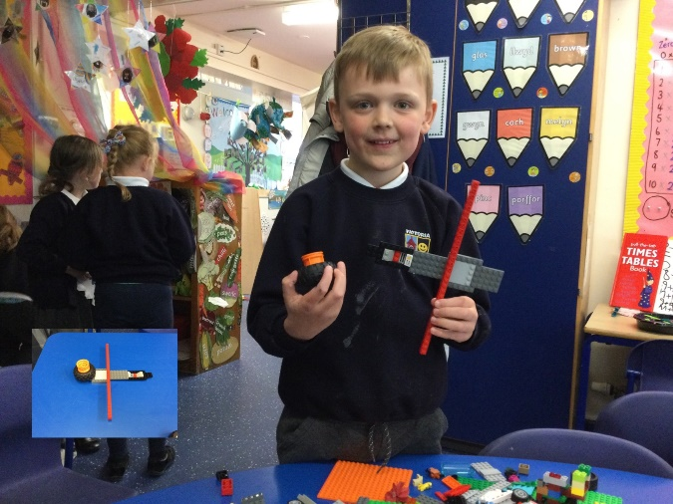
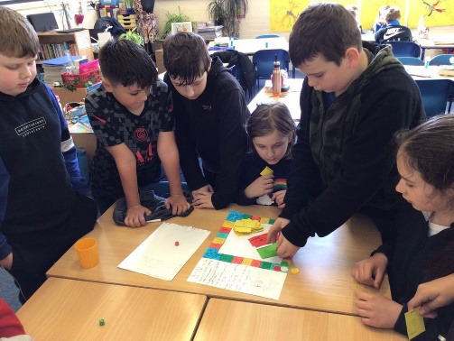
We give the children agency - a purpose and meaning to their learning. We capitalise on technology and use it as a vehicle to empower our pupils and to use it to enhance their learning and their personal effectiveness as learners. Digital and scientific literacy are hugely influential in the world we live in, and we will enable our learners to shape a better future where they can positively influence their lives and the world around them.

We have a diverse learning community and it is important to us that we represent and serve all our pupils and families through our diverse and rich curriculum. We want every child to know that anything is possible - that there are no barriers to learning at Victoria CP School. We are a ‘Rights Respecting’ and ‘Peace’ school, and we pride ourselves on being an inter-cultural school where the Rights of the Child thread through everything we do.

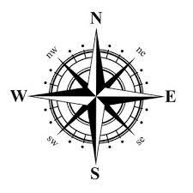
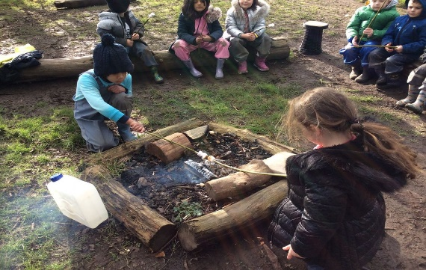
Whole School Curriculum Overview
We have been designing our bespoke curriculum through Cornerstones Maestro for 2 years. We will complete the 3-year subscription next year and then continue to design and build on the comprehensive, personalised and dynamic curriculum we have already created. Cornerstones has enabled us to seamlessly build in coverage and progression points which has enabled staff to focus on pedagogy and creating innovative learning experiences for our learners.
