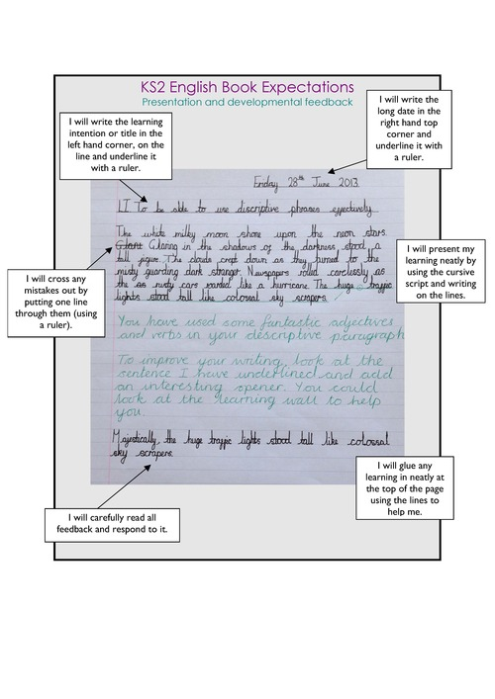 

**BE PROUD OF YOUR WORK – IMPROVE ON YOUR PREVIOUS BEST!**

**BE PROUD OF YOUR WORK – IMPROVE ON YOUR PREVIOUS BEST!**