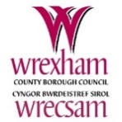
A parents and carers guide to religious education in community schools, foundation, and voluntary schools without a religious character in Wrexham from September 2022

The new name for Religious Education in the Curriculum for Wales is Religion, Values and Ethics (RVE).
The RVE your child will receive must be pluralistic. This means that RVE:
- must reflect the fact that religious traditions in Wales are in the main Christian while taking account of the teaching and practices of the other principal religions represented in Wales
- must also reflect that fact that a number on non-religious philosophical convictions are also held in Wales
RVE is mandatory for all learners from ages 3 to 16 in Wales. This means, that from September 2022, parents and carers of primary school age children will not be able to withdraw their child from RVE.
This may come as a bit of a shock to some of you, but please don’t worry. Your child’s school must provide RVE that is objective and critical both in content and pedagogy, which means that all teachers must take a non-confessional approach to the exploration of any faith, belief or denomination. RVE is not about making learners ‘religious’ or ‘non-religious’, and schools in Wrexham recognise this. They will provide RVE that is planned sensitively and delivered with professional integrity.
In addition to this, RVE now sits within the Humanities Area of learning and experience. This means that your child’s learning in RVE may not take place in a separate lesson, as it may have done before, but rather in an integrated way with other Humanities subjects, like history and geography. From time to time, RVE may also be integrated with other subjects in other areas, including for example, music, art, or science.
Every primary school in Wrexham will be designing its own curriculum for September and each school must have regard to the Wrexham Agreed syllabus for RVE and the Welsh Government statutory guidance on RVE when doing so. These documents will provide them with a framework within which they can best design their own local curriculum which includes RVE within the Humanities Area.
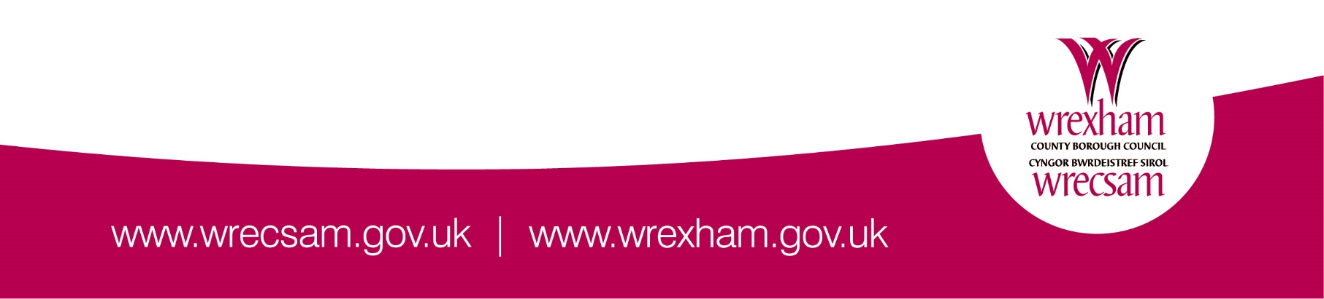
If you have any questions about the above changes, or what your child might be learning about in RVE from September, please contact the Headteacher of your child’s school in the first instance.

